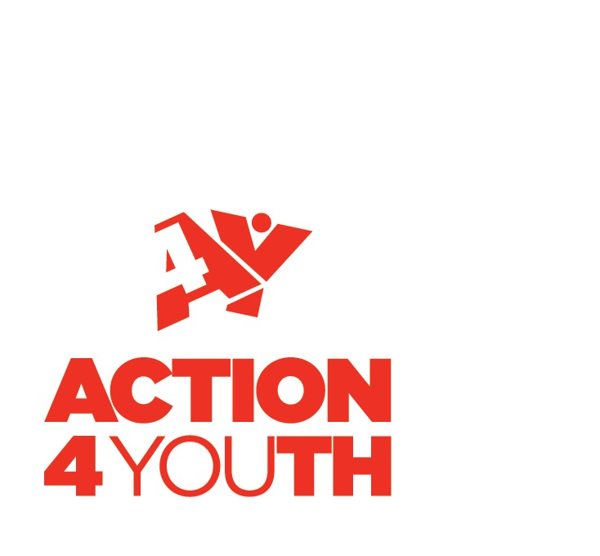
MENTORING
REFERRAL FORM
for Young Persons aged 11-18

- Details of person making a referral (person completing form)
_____________________________________________________________________________________

Name:

Role (if applicable):

Contact Details:

Telephone number:

Email address:

- Young person’s details
_____________________________________________________________________________________

Name of young person:

Address:

Telephone number:

Email:

Date of birth:

Disability/ additional needs: Yes No

If ‘Yes’ please detail below.
………………………………………………………………………………………………………………………………………………………….
………………………………………………………………………………………………………………………………………………………….
…………………………………………………………………………………………………………………………………………………………..

What are the young person’s views about this referral and what would they like to achieve?

Consent by young person to be referred.
Parental/ Guardian consent given

- Emergency contact details for young person
_____________________________________________________________________________________

Name:

Address:

Telephone number:

- Reason for referral: (please indicate if previous referrals have been made and attach any relevant information)
_____________________________________________________________________________________

1 What are you concerned about?

2 What is the impact on the young person? (please give examples)
3 What support will you continue to offer/ is already in place for the young person and/ or family?

4 Who else is working with the individual/agencies?

- Data Protection
_____________________________________________________________________________________

Privacy Notice

Action4Youth will collect personal information from you when you or your organisation enquire about our activities, register as a member or subscribe to one of our services. This may include your name, title and email address, physical address, telephone number and job title. We may also ask for some additional information. Your personal information will only be used to process your requests, to provide you with our services, and to provide you with information relating to our services and all other services that we think you may be interested in. We will only share your information with partners who are directly involved. Your information will be held for a maximum of 36 months. You have the right to withdraw at any time and to ask for your data to be erased and you have the right to lodge a complaint if you are not satisfied.

- Consent
_____________________________________________________________________________________

I agree for this referral to be made to Action4Youth and I understand that they may contact other agencies for information sharing purposes between the agencies. I also agree to engage with agencies for assessment and /or support.

Signed:

Name:

Date:

- Risk Assessment of Young person
_____________________________________________________________________________________

(Please tick) No risk low Medium High

A risk to themselves:

A risk to others:

Please include a risk assessment if young person is high risk.

- Other Agencies
_____________________________________________________________________________________

Are other agencies already involved with this young person? Yes No

If ‘Yes’ please list details of agency and contact.

What support have other organisations provided?

What are the parent/carer views about this referral (if applicable)?

- Attachments.
_____________________________________________________________________________________

Please add any supporting information to this referral.

Please return all electronic referral forms to: office@action4youth.org with the subject: Mentoring Referrals.

