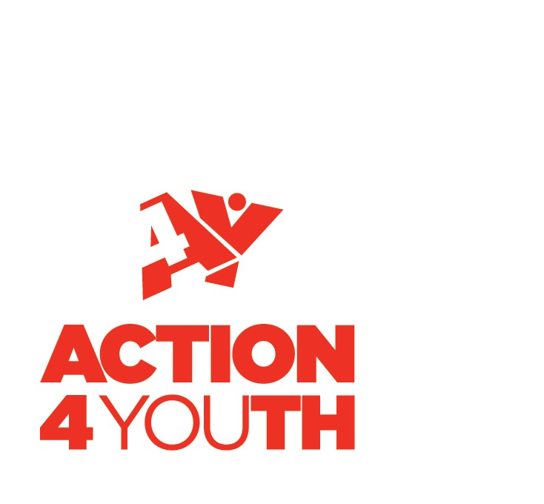
MEMBERSHIP
APPLICATION FORM
2020/2021 1st April – 31st March
Membership No.
(office use only)

Youth Project/Club/Organisation
(please complete this form in block capitals)
_____________________________________________________________________________________

Name of club/organisation:
Postal address of club/organisation’s meeting place:
Telephone number:
Email:
Website and/or Logo (logo in pdf format if possible):

Primary Contact
_____________________________________________________________________________________

Name of Contact:

If contact details are different from above, please state, address, telephone number and email contact details below:

Please tick this box to receive our Newsletter and information from Action4Youth. We will not share your information with any third parties.

Chair Contact Information
___________________________________________________________________________________

Chair’s name:

Telephone number:

Email:

Please tick this box to receive our newsletter and information from Action4Youth. We will not share your information with any third parties.

Staff
_____________________________________________________________________________________

Do you have paid members of Staff?  If YES, please confirm the number below: | Do you have Volunteers?  If NO, please confirm the number below:

Meeting/Membership Information
_____________________________________________________________________________________

We would like to know a bit more about your club/organisation so could you please complete the following:

Meeting times of your club/organisation

Day | Monday | Tuesday | Wednesday | Thursday | Friday | Saturday | Sunday
Time

Any other additional information:

Age Range of young people attending your club/organisation

Age range | 5-7 | 8-12 | 13-15 | 16+
Number

Any other additional information:

Insurance Information
_____________________________________________________________________________________

YES or NO  (please delete as appropriate) | If YES – Name of insurer:

Membership Fees and Payment
__________________________________________________________________________________

Once we have received your completed membership form, we will send you an invoice.

The annual membership fee for 2020/2021 is £100 and starts from April 1st to March 31st.

Please provide details of your treasurer or contact who looks after your club/organisations’ accounts in the box below:

Name:
Email address:

Data Protection
_____________________________________________________________________________________

Privacy Notice
Action4Youth will collect personal information from you when you or your organisation enquire about our activities, register as a member or subscribe to one of our services. This may include your name, title and email address, physical address, telephone number and job title. We may also ask for some additional information. Your personal information will only be used to process your requests, to provide you with our services, and to provide you with information relating to our services and all other services that we think you may be interested in. We will only share your information with partners who are directly involved. Your information will be held for a maximum of 36 months. You have the right to withdraw at any time and to ask for your data to be erased and you have the right to lodge a complaint if you are not satisfied.

Declaration
_____________________________________________________________________________________

I confirm that the group/organisation named on this form wishes to apply for membership of Action4Youth and that the information supplied in this form is accurate.

Signed …………………………………………………………………………… Date ………………………………………..

Name ……………………………………………………………………………..

