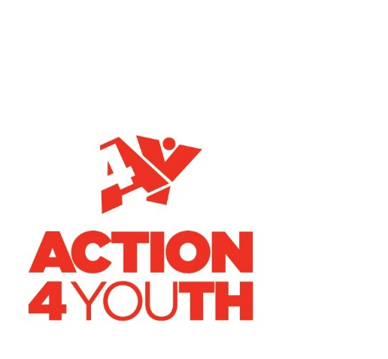

Development Volunteer

Appointment Brief

Development Volunteer

If you want to change lives, call us - we want to hear from you!

Become part of a dynamic charity, with a great mix of people committed to making a real difference for young people through a range of fun and challenging programmes and initiatives.

Action4Youth provides transformational experiences for children and young people of all abilities and disabilities across Buckinghamshire and Milton Keynes. Our services help young people to overcome challenges, raise aspirations and develop vital skills that broaden their horizons and prepare them for life and work.

The organisation is currently in a period of ambitious growth as it increases its influence and reach. You will join a supportive, driven, committed team whose desire to achieve is matched by an intention to enjoy work on a day to day basis.

Our Corporate Strands

- Outdoor adventure and learning
- Programme Delivery – our Inspiration Programme and other programmes are designed to enable young people to discover their strengths and optimise their potential
- Infrastructure Support

Our Corporate Goals

- To provide outdoor education to enable young people to grow and develop
- To provide fit-for-purpose, demand-led infrastructure support that strengthens the capacity of youth organisations and enhances their voices and influence
- To deliver, in addition to outdoor education, a range of frontline services which contribute directly to the Action4Youth mission

What we do

Action4Youth is a leading delivery partner for the National Citizen Service (NCS) and consistently over delivers in terms of both quality and quantity.

Action4Youth takes the strategic lead for the voluntary organisations supporting children and young people aged 5 – 25 years across its area. It has around 100 organisations in membership and offers a range of essential support and services.

Our outdoor centre, Caldecotte Xperience in Milton Keynes, creates opportunities for young people to have amazing, challenging, fun and sometimes transformational experiences. They learn what they can do rather than what they can’t, building their confidence and self-belief.

Action4Youth is the operating authority for Buckinghamshire and Milton Keynes for Open Awards Groups for the Duke of Edinburgh Award Scheme.
Job Description

Job Title
- Development Volunteer

Location
- Aylesbury, Buckinghamshire

Position in the Organisation
- Reports to: The Fundraising Manager
- Working with: The Development Team and wider Action4Youth Staff Team

Main Purpose and Scope of the Role
- To support Development Team members in researching and approaching prospects, with the aim of securing funds, increasing use of Action4Youth services and engaging companies and organisations in our work

Duties and Key Responsibilities
Duties will depend on the teams’ current priorities and activities, but are likely to include:

Desk-based research (using phone and internet) to support existing team activity
- Sourcing contact details, telephone numbers and email addresses for schools and community organisations
- Researching companies to find out information about their charity giving policy
- Competitor analysis to help identify gaps in the market and highlight new ideas for fundraising activity

Fundraising approaches
- Drafting applications for supermarket token schemes
- Writing to community groups including rotary clubs, masonic lodges and WI groups
- Exploring opportunities for partnering third-party community events which benefit local charities

Other duties
- Data entry – keeping the charity’s database up to date (full training given)
- Assisting with mailshots to e.g. schools and companies
- Assisting with event organisation

General Responsibilities
- To have regard for Action4Youth’s vision and mission, and to display a commitment to equal opportunities and to the protection and safeguarding of young people
- To report any behaviour, conversations or comments which are inappropriate within a setting for children and young people
- To take responsibility, as part of the team, for all Health and Safety work related matters
- To work within the guidelines of Action4Youth policies and procedures
Person Specification: Development Volunteer | Essential (E)  Desirable (D | Demonstrated at:  Application (A)  Interview (I)
An interest in helping children and young people and enthusiasm for the work of Action4Youth | E | I
Experience of working in a voluntary capacity | D | A
Excellent written and spoken communication skills and an ability to communicate well at all levels | E | I
Strong computer skills (experience using Microsoft Office and databases) | E | I
Strong desk-based research skills | E | I
Ability to work alone using own initiative | E | I
A team player who is outgoing, friendly approachable, flexible and enthusiastic | E | I
Strong interpersonal skills, tact, sensitivity and diplomacy | E | I
An understanding of the ethos, values and culture of Action4Youth | E | I
Demonstrate an awareness of equal opportunities | E | I
Current driving licence and use of a vehicle | D | I

Time commitment
The time commitment is flexible and will depend on our current activities and projects, but we suggest a minimum commitment of 1 day per week (or two half days) for an initial three-month period.

To Apply
To apply for this role please send a CV and supporting statement to Jan Knight, HR and Admin Manager via email jan.knight@action4youth.org. The supporting statement should concentrate on addressing the skills and experience requirements of the person specification above.

There is no closing date for this position. It will remain open until we find the right person.

If you would like an informal chat regarding the role, please email Rosalind Lee, Fundraising Manager rosalind.lee@action4youth.org or call 0300 003 2334.

Action4Youth
5 Smeaton Close
Aylesbury
Buckinghamshire
HP19 8UN

Telephone: 0300 003 2334
www.action4youth.org

